Johann THUILLIER 336104120.
Samuel BISMUTH 342533064.

- Assignment 6 -

Task 1 -

Question 1 -
GET /rfc/rfc793.txt HTTP/1.1
Accept: image/gif, image/x-xbitmap, image/jpeg, image/pjpeg, application/x-shockwave-flash, application/vnd.ms-excel, application/vnd.ms-powerpoint, application/msword, application/xaml+xml, application/vnd.ms-xpsdocument, application/x-ms-xbap, application/x-ms-application, */*
Accept-Language: en-us
Accept-Encoding: gzip, deflate
User-Agent: Mozilla/4.0 (compatible; MSIE 6.0; Windows NT 5.1; SV1; .NET CLR 2.0.50727; InfoPath.1; .NET CLR 1.1.4322; .NET CLR 3.0.04506.30; .NET CLR 3.0.04506.648)
Host: www.ietf.org
Connection: Keep-Alive

Question 2 -
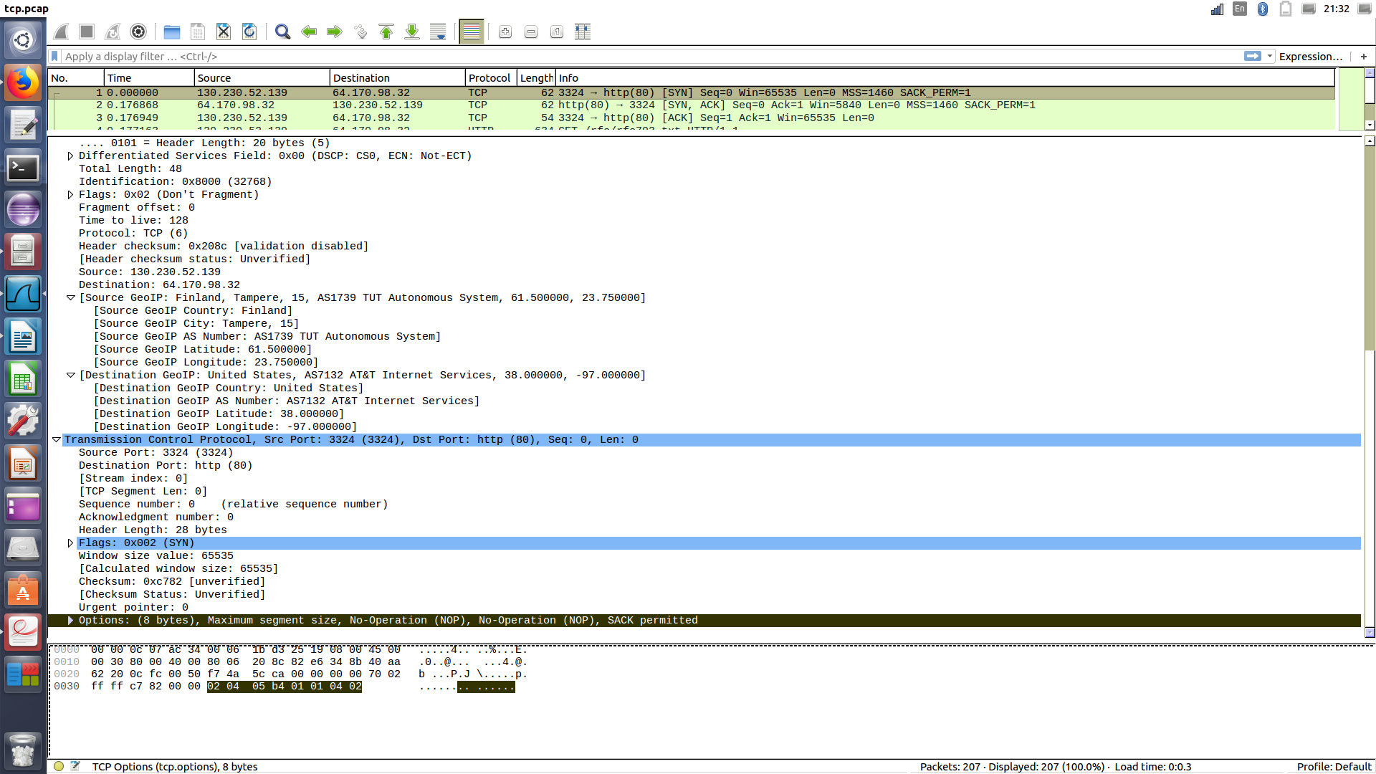
Screen-shot from wireshark.

For the client the OPTIONS are : PSH and ACK.
For the server the OPTIONS are : ACK like we can saw in the picture.

Question 3 -
The MSS of the computer is 1460.
The MSS of the server is is also 1460.

Question 4-
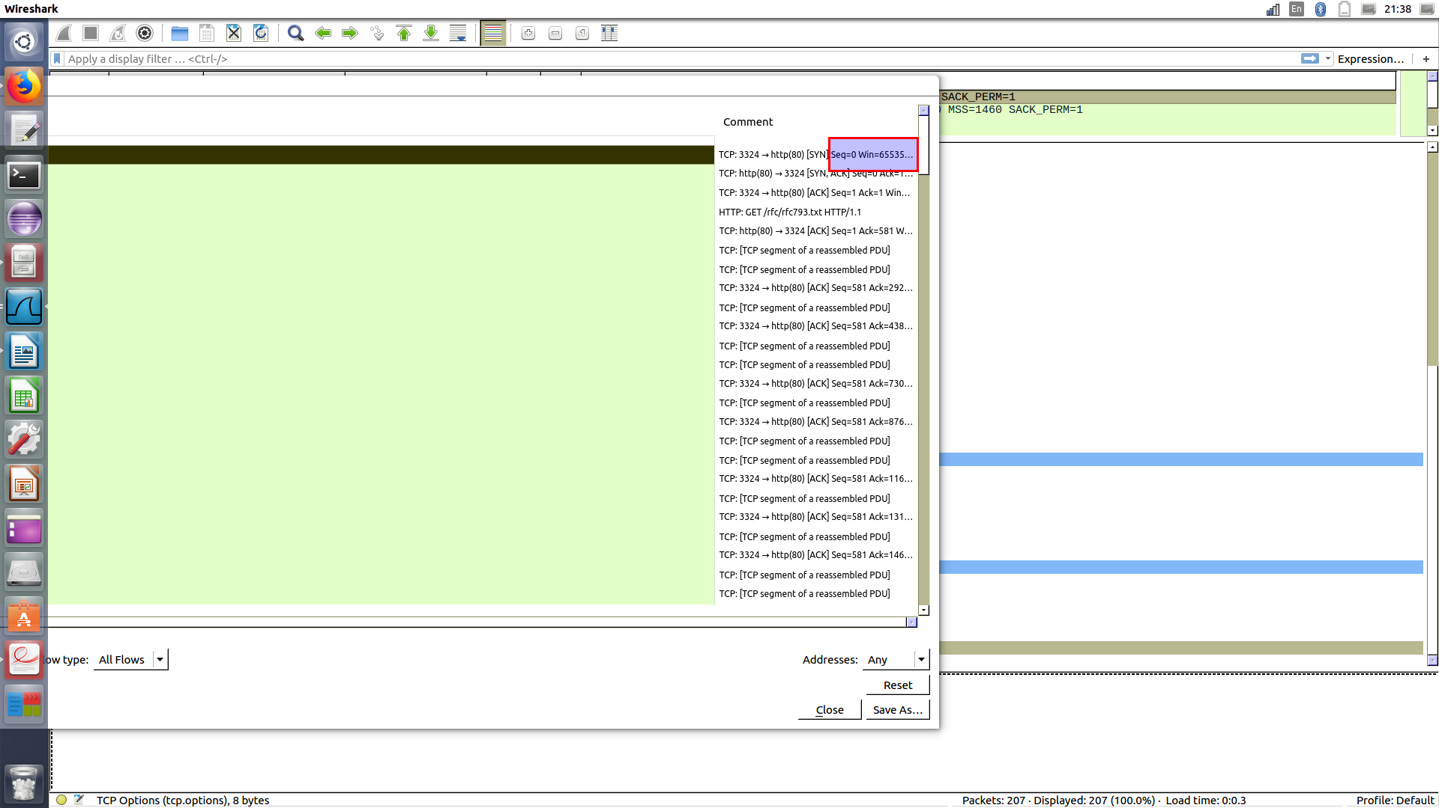
Screen-shot from wireshark.

WINDOW65535

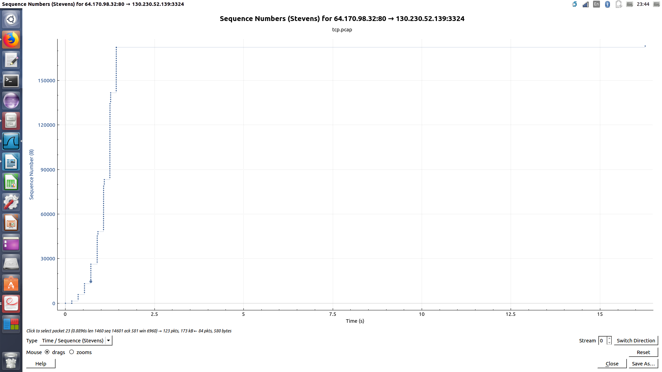
Question 5-
Screen-shot from wireshark of the sequence numbers (Stevens).

According to the graph we can see that when the amount of information passes properly the bandwidth width is increased twice.

Question 6-
a) The flag always on is ACK.
b) The fields that do not change are the src port, the dest port, and the serial number.
The src port is basically the filed that contains the port number of the source computer.
The dest port is basically the filed that contains the port number of the destination computer.
The serial number is actually the segment number (32 bit).
c) The fileds that change are FIN, ACK, SYN, and CHEKSUM.
The FIN announces the end of the connection.
The ACK approves the receipt of the information.
The SYN announces the stage of establishing the relationship.
The CHEKSUM is the hash of some value, to make sure tgar the data consistent when it gets to other end. He is taken before the data is sent and when the data is received at the other, the checksum of the same value is taken again. Both checksum are matched and compared.

Question 7-
For the first conversation 1-13:
The SYN is off in the second package so he don’t know with which segment to start ACK UNSEEN.
The connection was not established properly.
For the second conversation 15-17:
In package 16, the ACK flag is 0, which means there is no flag to confirm the receipt of a message.

Question 8-
The client received a message which say that his request did not reach the server but was notified that the message had arrived.

Question 9-
Source port : 1593.
Destination port : 12209 .

Question 10-
The header size of the TCP packet is greater than the UDP, then it takes more longer for these packets to be sent.
In addition, the TCP packet are more reliable so they also wait for a message confirmation that the package has reached its destination. The UDP do not waiting for a confirmation.

Question 11-
The IP address of the source : 84.229.173.71.
The IP address of the destination : 109.64.17.214.

Question 12-

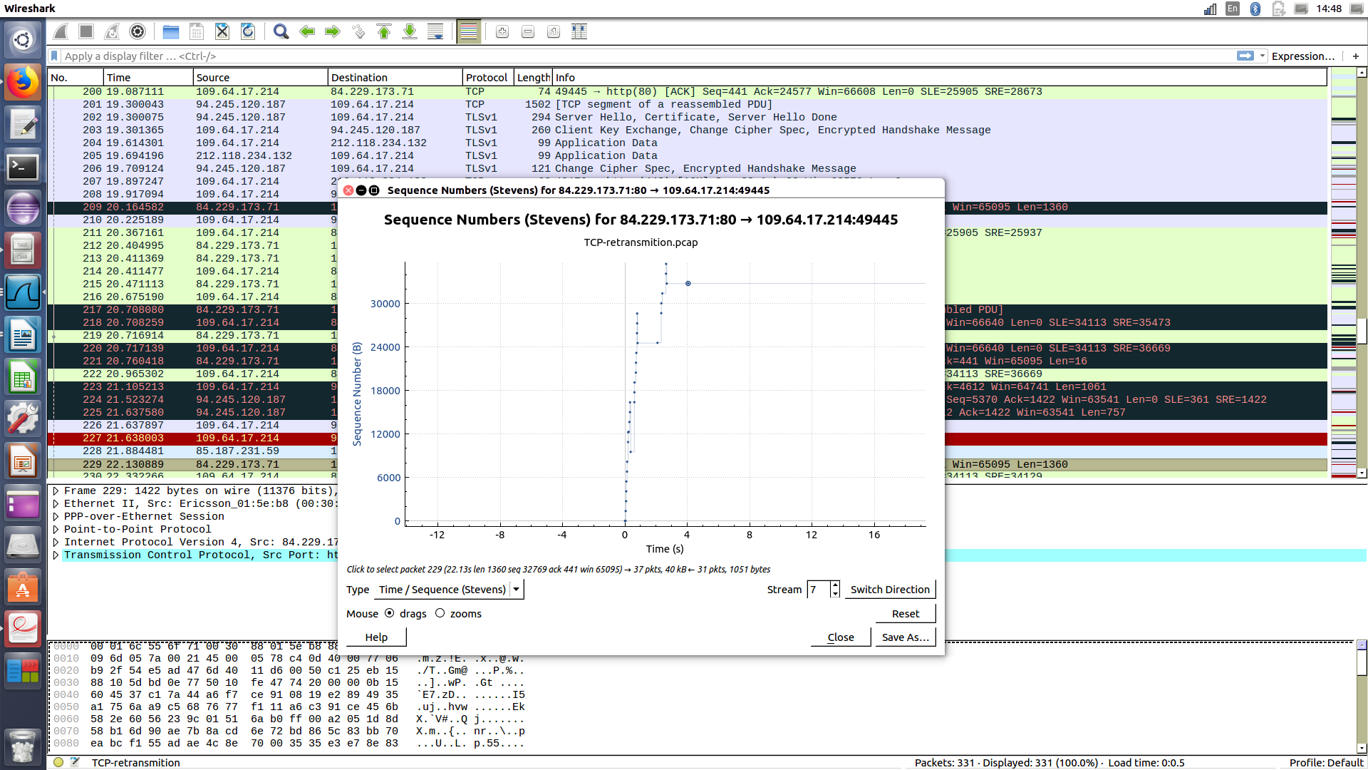
Screen-shot from Wireshark of the sequence numbers (Stevens).

As we can see in the picture above, we notice a linear increase from the package number 151.

Question 13-
When there is a disconnect from the Internet, or a sudden shutdown…

Task 3 -

Question 1-
Wrar371.exe
Question 2-
The client maximum windows size is 1460.
The conversation at the beginning of the server window size is 5840.

Question 3-
At this time, the client’s reception window is 0, and therefore, the client can’t receive information from the server and at 3.9 seconds, the window is greater than 0, so he is able to receive information from the server.

Question 4-
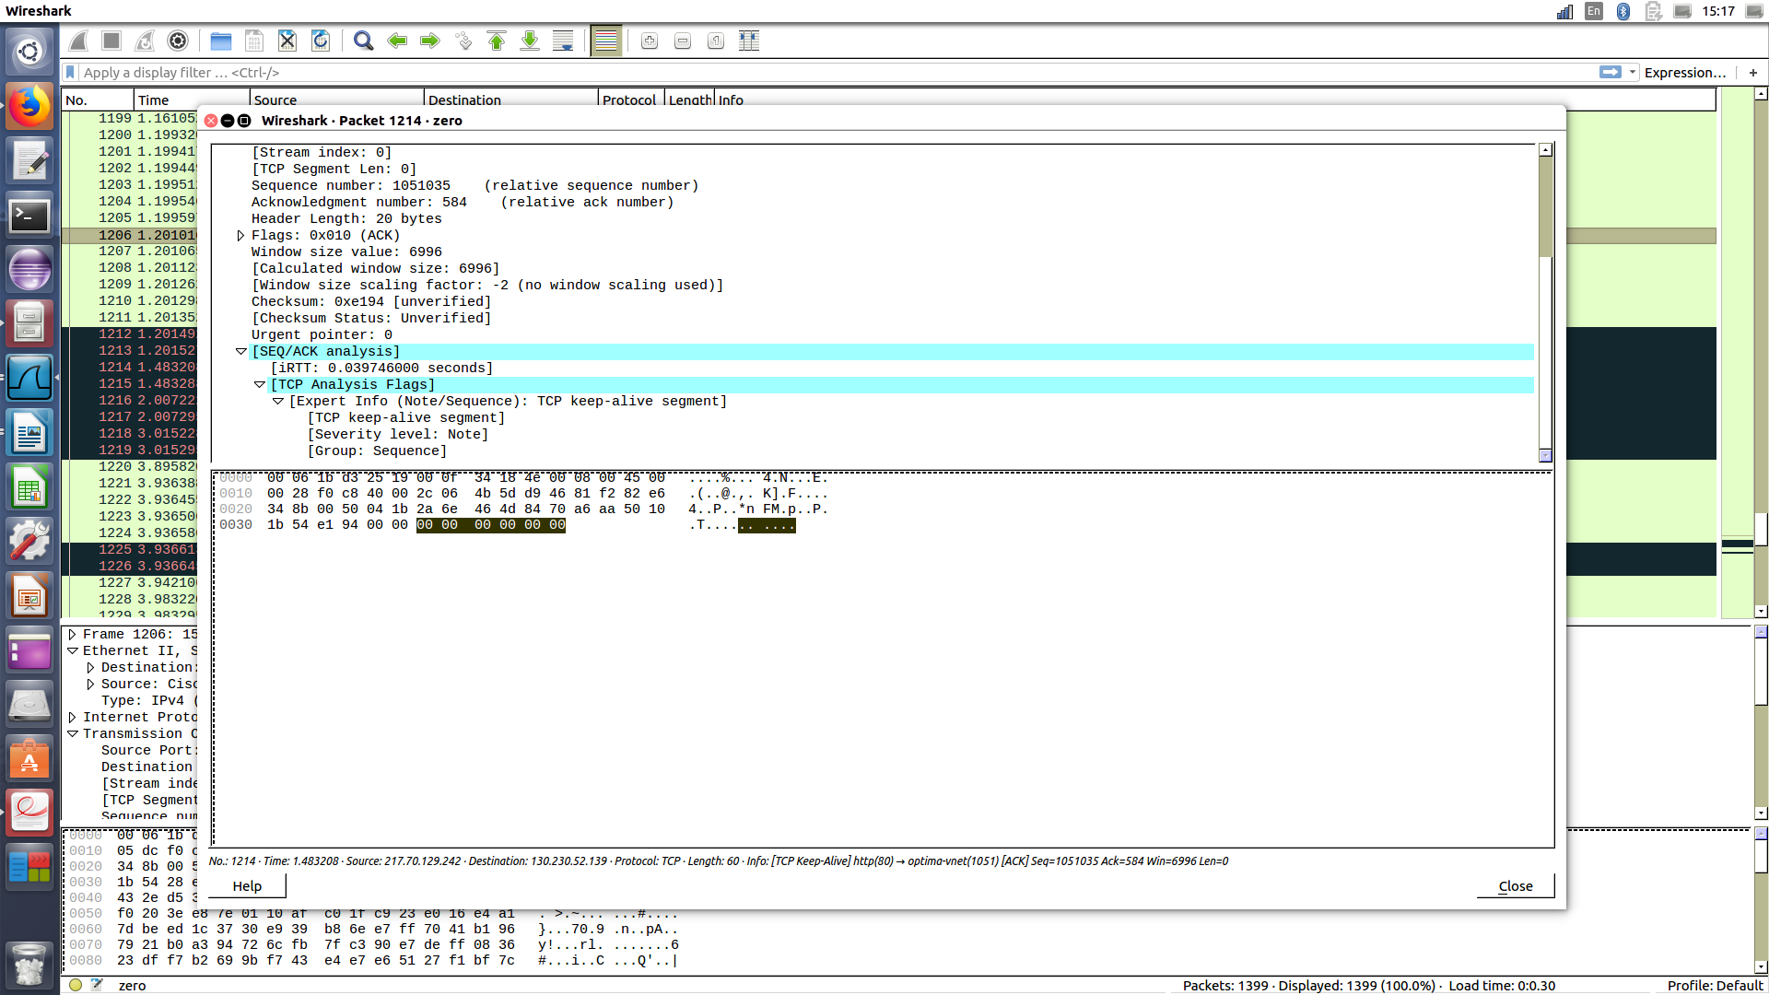
Screen-shot from wireshark of the detail for the packet number 1214.

Question 5 -
The time for the packet number 1213 is 1.201527.
The time for the packet 1214 is 1.483208.

ROT = 1.483208 - 0.281681 = 1.201527

Question 6 -
Let see the following example :
Between the 1214 and the 1216 packets
the time 1.483208 jump to 2.007222.

as we can see, the server expands the gap between Keep-Alive Packets Exponentially.

